
Loyalty Tri-V Umph
Cooperation June 2010
Friendship

President-M.Trachsel-586-484-0836 Sec.-D. Angelosanto-734-422-3501
V. President-M. Van Hollenbeke-734-765-2555 Treas.-J. Mackson-734-525-0537

President’s Message

I hope everyone is enjoying the nice warm weather as much as I am this year. The golf season is in full swing and we all had a great time at the May Open House. The Anniversary party was a really nice time this year as usual. The entertainment was good and the company even better! This month we will be initiating a new member to our club. I hope you all have had an opportunity to get to know Jason. I know he will make a great addition to the club.
God Bless,
Mike T

Book Club

The next book club discussion will be held on Monday, June 21 at Karlyn Gies--7:00 p.m.
Book we are discussing is "Liars & Saints" by Malie Meloy. Also suggested for an upcoming month is "The Same Kind of Different As Me" by Ron Hall and Denver Moore. I checked and there are many copies of this book at the library. Book was suggested by Peg Hoffman.

TRI-V Wives Weekend Getaway

This year we are going to the Mannsiding Lodge Bed & Breakfast in Harrison, Michigan from August 20th to August 22nd.The cost per night for a single occupancy king/twin room is $102.60 and double occupancy is $51.30 each. The cost per night for a single occupancy queen room is $92.34 and double occupancy is $46.17 each. As of this writing the 2 king and 2 twin rooms have already been booked. There will be additional expenses for 2 lunches and 1 dinner, gas money for the drivers and a pontoon boat ride at Houghton Lake. The Lodge has several amenities such as a private movie theatre (feel free to bring a DVD to share), hot tub, central air, rooms for playing cards and games, and several nature trails for the adventurous and an elevator for easy access to the rooms. Jan knows the owners John & Donna Hudson personally and can confidently say it is a nice quiet getaway for our group. Donna Hudson will be preparing our dinner Saturday evening and she is a great cook. So to all Tri-V wives (not just members) or their significant other, please let one of the committee members know by June 15th if you would like to come and enjoy a fun filled weekend with the girls.

Jan Cashman 248-669-9209

Ellie Connolly 248-473-8414

TRI-V Steak Roast
Saturday, August 14, 2010

The Steak Roast will be held at Gunner Mettala Park in Wixom at the main pavilion shelter. The park is located on Maple Road (15 Mile Road) between Beck Road and Wixom Road (closer to Beck Road). The committee will be there at 2:00pm and dinner will be at 5:00pm so come early and enjoy the great outdoors. There are tennis courts, baseball fields and walking paths available if interested in some side activities. Also you are welcome to bring any other games you would like to play.

Remember to bring your chairs, place settings and beverages. The main menu will be NY strip steak, corn on the cob, salad, dessert and coffee. See you there! Chairman-Cal Cashman

Tri V Final Golf

FINAL GOLF is August 20, 21 &22 at Ray’s Retreat in Gaylord. If you are planning on going and haven’t told the committee and paid your $100.00 deposit, please do so now. We need to give a final number to the hotel soon in order to get the place to ourselves like last year. Don’t delay do it today.

Committee Jay Trachsel Brian Trachsel Steve Trachsel

JULY PICNIC

The Tri-V Family Picnic will be held on Sunday, July 18, 2010. It will be held at Gunnar Mettalla Park, 645 Mettala in Wixom. This is the same location it has been held in the past few years. Mettalla Park is off Maple Road, west of Beck Road.

Picnic begins at 12:00 noon with lunch at 1:00 pm.

Games for little ones and adults will follow lunch--there will be some new FUN games this year for all to participate in.

This is a FAMILY PICNIC so bring all of your family with you. The committee asks all families attending (even guests) to assist in preparing the luncheon buffet. Each family is asked to bring a dish to share that serves 12-15 persons. We are always in need of casseroles. Other dishes include salads, veggies, fruits, and of course, desserts (preferably those that can be eaten by little ones without a big mess) i.e. cookies, brownies, finger jello, etc. REMEMBER to bring your own place settings, drinks, ice, lawn chairs, games, etc. Anyone who has sponsored a Prospective Member, please invite them as well.

In past years the Tri-V Wives club has asked people to sign up for the dish you plan to bring but in the past the response has NOT been great. This year there will NOT be a sign-up sheet.

If you have any questions, please call Mike Lardin 734-404-5132 or 734-536-1345.

Mike Lardin, committee chairman

New Arrival

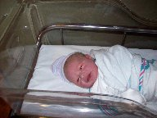
Congratulations to Mike and Bev Lardin and Grandparents,John and Judy Lardin on the arrival of Alyssa Veronica. Alyssa was born on June 1, 2010 at 7:22 pm weighing in at 8 lbs. 2 oz; 19.7 inches long. Everyone is doing great. Alyssa is the eleventh Grandchild for John & Judy.

Trifles

From the Reutniks
Dave Ruetenik is now at Lakeland Nursing Home located at 26900 Franklin Rd. in Southfield. That is located close to Telegraph and 11 Mile Rd. He seems to now be in the right facility and they are able to care for him. He of course wants to come home. Geri is now in the middle of another round of chemo. She looks well and says she is not as tired as she was before. It will be a couple of weeks before she will find out if this is working. Notes, cards phone calls are always welcome for both and of course; please keep them both in your prayers.

From the J. Lardins
By now most are aware of God’s gift to the Lardin family with the birth of Alyssa Veronica to Bev and Mike Lardin. Bev’s due date was June 1st and after two trips to St. Joes on the 1st they kept her and Alyssa was born at 7:22 PM. Hard to tell who was most excited, Bev, Grandma or Grandpa but Grandpa thinks the most excited goes to Daddy Mike. All are doing well and you can bet you money that Alyssa will be spoiled beyond repair.

From Macksons
Robyn and John are eagerly awaiting the arrival of the third little one. They recently got to spend some time by themselves as Dominic and Madison went up north for the holidays with John’s parents. We were able to see a comedy show and of course head to the casino. John made stops in Mt. Pleasant and the fabulous Greektown Parking Garage. Robyn is happy that her Seniors are gone and that school will be over soon.

From A. Trachsel
Art Trachsel has decided to sell his condo in Sarasota FL and has listed it with a realtor. Once it sells, he plans to move back to Michigan to be close to Ken and Diane.

From Betty Galloway’s Daughter, Sandy

Hi everyone.......Mom asked me to email all of you in case you've been wondering how she was doing, where she was, etc. In late April, Mom was transferred to a rehab facility here in Mt. Pleasant for strengthening and PT care. She's been doing well overall, just very slow going. However, a week ago she had another setback and was re-admitted to the hospital. It's been a tough time for her, but she's a fighter overall and determined to get back to rehab and then come home. Today's been a good day as she was able to start soft food, so hopefully she can get back to rehab on Monday. Keep your fingers crossed, and say lots of prayers for her if you can. Every little bit helps! :)

If you'd like to reach me directly, my email is se2murphy@yahoo.com. For those interested, Mom is at Central Michigan Community Hospital now, and hopefully going back to the Medical Care Facility early next week. I know she'd love to hear from all of you!

Sandy

From the T. Gies
Tim Gies says he is going to the next level of retirement (did you know there are levels) and will be spending Jan, Feb & March in Florida this year, without working. He will come home and work April & May and as much as he wants to the rest of the year. Tim and Karlyn also have a month trip planned in Oct to first go to a Clemson football game with his nephew and then down to Hilton Head to stay with his brother Dave and wife Sandie and the Clingermans.
Karlyn Gies traveled with daughter Tracey and her two children to daughter Lisa's in Pennsylvania for five days the end of May. Lisa has two boys ages 6 and almost 3. Tracey's two are almost 4 and 19 months. It was a wonderful visit. The kids really got to know one another. They taught each other all kinds of things, most of them good. We went to Hershey Park one day and they all loved the rides. This will be an annual trip from now on.

From the Clingermans
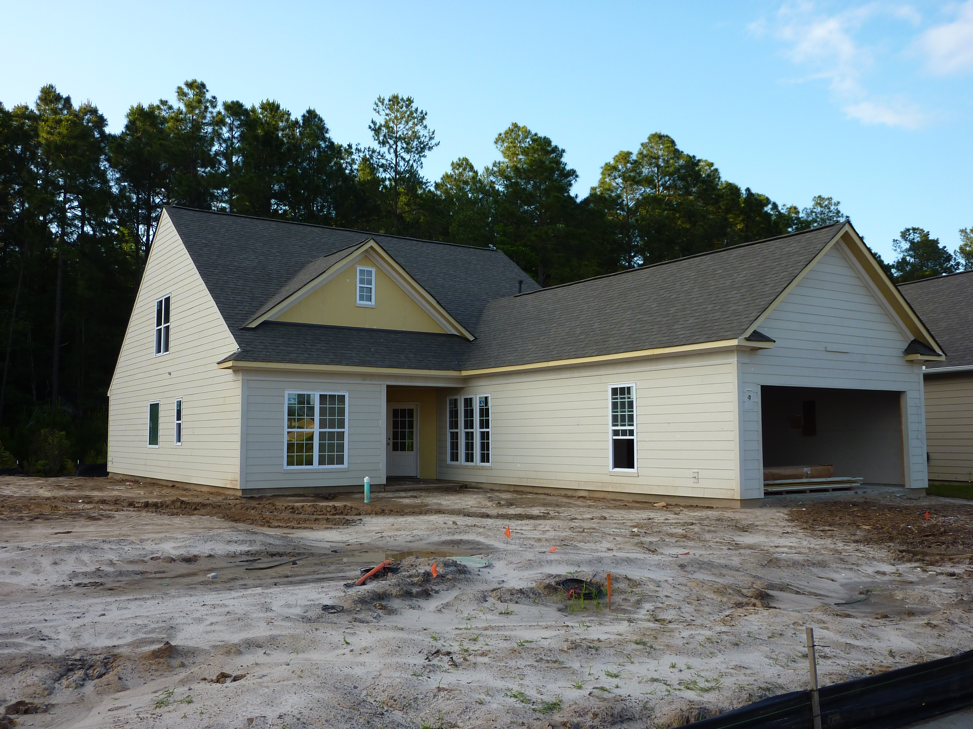
I just want to make sure John gave you our permanent address, not our rental, for the TRI V roster.
654 Serenity Point
Bluffton, SC 29909
At this point our phone is my cell: 248-417-1289
That will probably change once we move in.
There is soooo much to do around here it's going to take awhile to see everything. I'm attaching a picture of the house in progress. We have drywall already!

From G. Hoffman
A LARGE thank to all of the Tri-Vers for the support during my recent surgery. The Tummy tuck went well with only mild discomfort. I am recovering well and hope to be at initiation, but golf is still a couple of months away, since my incision round across my whole stomach. Thanks again.....

Calendar of Events

June July 7th Tri-V Golf League 5th Tri-V Golf League
(Hickory Hills 4:30 pm) (Hickory Hills 4:30 pm)
11th Initiation 12th Tri-V Golf League
(Walker’s Speakeasy) (Hickory Hills 4:30 pm)
14th Tri-V Golf League 18th Tri-V Family Picnic
(Hickory Hills 4:30 pm) (Gunnar Mettala Park 12 pm)
21st Tri-V Golf League 19th Tri-V Golf League
(Hickory Hills 4:30 pm) (Hickory Hills 4:30 pm)
21st Book Club 26th Tri-V Golf League
(Karlyn Gies 7:00 pm) (Hickory Hills 4:30 pm)
28th Tri-V Golf League
(Hickory Hills 4:30 pm)

June Birthdays July Birthdays
2nd Jim Delanoy 4th Dion Angelosanto
8th Marilyn Myers 5th Roy Lockhart
12th Jay Trachsel 21st Michael Trachsel
14th Virginia Buckley
22nd Joan Fischer

June Anniversaries July Anniversaries 6-4-94 Ken & Diane Plocharczyk 7-9-83 Dave & Geri Ruetenik
6-5-48 Bill & Shirley Suchner 7-14-45 Bill & Onalee Trachsel
6-14-02 Dion & Annemarie 7-17-65 Terry & Ellie Connolly
Angelosanto
6-21-08 Mike & Bev Lardin
6-22-48 Lee & Marian Anderson
6-23-01 John & Robyn Mackson
6-29-63 John & Judy Lardin
Tom & Bonnie Untener

MEMORIES FROM THE JUNE 2000 ISSUE OF TRI-V UMPH

I think the June 2000 issue of the TRI-V Umph and more people in need of our prayers than any of the
past six recent issues. We start out with Curt Martin who took a spill on the wet stairs and ended up
with slightly torn ligaments around the kneecap. Art Trachsel underwent successful cataract eye surgery,
the right eye done the end of May followed by the left eye in June. Pat Foley was having trouble with his
right hand and the doctors determined that is was carpal tunnel and was to face surgery to correct it. Cy
Richeson was suffering with a stubborn attack of bronchitis and this was forcing him and Dorothy to change
their travel plans. Jim DeLanoy underwent gall bladder surgery the middle of June. Fortunately the
surgery was done laparoscopicly and enabled Jim and Doris to make their planned Michigan trip. Beecher
Todd was having urology surgery the end of July while Stan Reid had a triple by-pass done in April and
was also suffering from shingles of the eye at the time. Lastly Pat Reid had to have another two inches
taken off of her leg but the good news is that she still has her knee and can still have her artificial leg.
This was also the time of year to share the graduation of several TRI-V siblings. We start with Robyn
Angelosanto who was graduating from Michigan State and was to start her student teaching in the fall.
She was also newly engaged to John Mackson who was graduating from Michigan State and was also
going to be a teacher as well as getting into coaching. Christina Bliudzius graduated from Western
Michigan and was to backpack through Australia then start her new job in Minnesota. William Trachsel
graduated from Central Michigan and was starting this student teaching at Clarenceville High School.
Gretchen Dunham was starting her Masters at Western Michigan and finally Kimberly Trachsel was
officially out of high school and heading for Western University in the fall.
There was a three page article on the TRI-V Wives 60th Anniversary Chicago Trip and the trip was
summed up as follows. The forecast for the weekend of June 9 – 11, 2000 in Chicago was “Hot and
Humid” It ended up being “Hot and Humid and Hilarious and Happy and Harmonious and Heady and
Healing and Heartfelt. I think I speak for everyone, when I day we all had a Hellava good time.”
The May Open House was well attended on May 14th with 50 golfers participating and 47 people
staying for dinner at Bogie Lake Golf Club, Commerce Township. Congratulations were extended to Mark
Elliott for the excellent job he did on the bowling league this year. The Steak Roast was set for August 12th
at Frasier’s Acres, Northville and Final Golf was set for August 25th through 27th in Jackson Michigan area.

MEMORIES FROM THE JUNE 2005 ISSUE OF TRI-V UMPH

The end of May found Sophie Ayotte admitted into St. Joseph Hospital for test that revealed a fast
growing malignant brain tumor. The doctors have told the family that it was various serious and the
TRI-V Family was asked to remember Sophie in our prayers. Our prayers also went out to the Steinhauer
family on the loss of Sherry’s father at the young age of 68. New members being sworn in at the June
Initiation were Geoff Steinhauer, William Trachsel and Matt VanHollebeke. The TRI-V Picnic was set for
July 10th at Gilbert Willis Park, Wixom, and the Steak Roast will also be at Gilbert Willis Park, Wixom,
on August 13th. Open House was held on May 14th at the Jackel Golf Course, Mt. Brighton with 32 golfers
making the event. The male Trachsel clan, 11 sons, son-in-law, grandsons and grandson-in-law, made
a special trip to Baltimore to join in celebrating a combined Birthday/Christmas present for Dad/Grandpa
Bill Trachsel seeing the Baltimore Orioles for a weekend of baseball. Bill has been a fan of the Orioles
going back when they were known as the St. Louis Browns. Judy and John Lardin were making another
trip to Texas to visit Larry, Kim and Christine the middle of June and Mike Lardin was going to Illinois to
Grandma’s to help her with a few things around the house and then traveling the end of June to Texas
to spend a week with Larry, Kim and Christine for a week. The travel would be coming to an end when
Judy was making a trip with her Mom and Aunt to Buehl Idaho to help celebrate her Uncle (Mom’s Brother)
80th birthday. This wraps up another trip down memory lane. Here it is the first of June and the beginning
of vacation season. The kids will be getting out of school in a week or so. Now would be a good time to
talk with them about what you did the first couple of summer vacation. Did your family start planning for
their vacation? Perhaps you were going to start a summer job of play some sport in a summer league.
If you were graduating from high school or college share the hopes that you had for the coming summer.
Don’t let those special times die in the back of your memory. Share them with your family and friends.
Until we see you next month in print, the Good Lord willing, take care of one another.

